*DAX: Measures vs. Columns - Explained with Examples*

Understanding When to Use Measures vs. Calculated Columns

This guide explains common DAX expressions using IF, SWITCH, SELECTEDVALUE, and more. It tells you whether each formula should be written as a measure or a calculated column, along with simple reasons.

DAX Summary Table

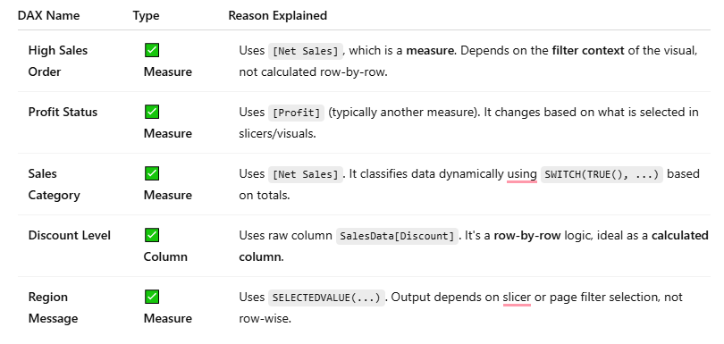

Quick Rules:

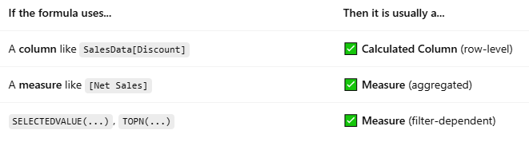

Tip:

* Calculated Columns: Stored in the data model, work row by row.
* Measures: Calculated on the fly, depend on visual filters, slicers, and aggregations.

*Note: All are going to be Measures except DISCOUNT LEVEL.*

Discount Level ✅ Column Based on raw column SalesData[Discount] (row-level)

**IF Function – *Simple Logical Test***

**Syntax:**

IF(condition, result_if_true, [result_if_false])

**What It Does:**

* Checks whether a condition is **true**.
* If **true**, returns one value; otherwise returns another.

**Example:**

Sales Category = IF([Net Sales] > 50000, "High", "Normal")

This returns "High" if Net Sales is over 50,000, otherwise "Normal".

**SWITCH Function – *Multiple Conditions***

**Syntax (Best Practice using TRUE()):**

SWITCH(

TRUE(),

condition1, result1,

condition2, result2,

...,

[default_result]

)

**What It Does:**

* Evaluates multiple **conditions in order**.
* Returns the result for the **first matching condition**.
* Think of it as a more readable way to do multiple IF statements.

**Example:**

Sales Category =

SWITCH(

TRUE(),

[Net Sales] >= 100000, "Gold",

[Net Sales] >= 50000, "Silver",

[Net Sales] > 0, "Bronze",

"No Sales"

)

This returns:

* "Gold" for sales ≥ 100,000
* "Silver" for 50,000–99,999
* "Bronze" for >0 but <50,000
* "No Sales" if zero

**When to Use**

One simple yes/no check --- use IF

Multiple ranges or categories --- use SWITCH

**1. Using IF – Conditional Logic**

**Example 1: Flag High Sales Orders**

High Sales Order =

IF(

[Net Sales] > 50000,

"High",

"Normal"

)

**Explanation:**

* Checks if net sales are more than ₹50,000.
* Returns "High" if true, otherwise "Normal".

**Tip:**

* Use in a **table or matrix** with Customer and Net Sales.
* Add conditional formatting to highlight "High" orders.

**Example 2: Profit Status**

Profit Status =

IF(

[Profit] < 0,

"Loss",

"Profit"

)

This is great for **product-level or region-level** evaluations.

**2. Using SWITCH – Multi-Level Categorization**

**Example 3: Sales Category**

Sales Category =

SWITCH(

TRUE(),

[Net Sales] >= 100000, "Gold",

[Net Sales] >= 50000, "Silver",

[Net Sales] > 0, "Bronze",

"No Sales"

)

**Explanation:**

* SWITCH(TRUE(), …) acts like nested IF.
* Returns the first match from top to bottom.

**Tip:**

* Add this to a column chart or donut chart.
* Helps students create **segmentation-based KPIs**.

**Example 4: Discount Range Category**

Discount Level =

SWITCH(

TRUE(),

SalesData[Discount] >= 0.3, "Very High",

SalesData[Discount] >= 0.2, "High",

SalesData[Discount] >= 0.1, "Moderate",

SalesData[Discount] > 0, "Low",

"No Discount"

)

Works best in visuals to analyze **discount strategies.**

**Example 5: Region-Based Message**

Region Message =

SWITCH(

SELECTEDVALUE(SalesData[Region]),

"North", "Welcome North Region Team!",

"South", "Welcome South Region!",

"East", "Hello East!",

"West", "West Side Strong!",

"Region Not Selected"

)

**Tip:**

* Use it in a card or dynamic title.
* Good example for SELECTEDVALUE + SWITCH.